Lab - Troubleshoot IPv4 and IPv6 Static Routing

# Topology

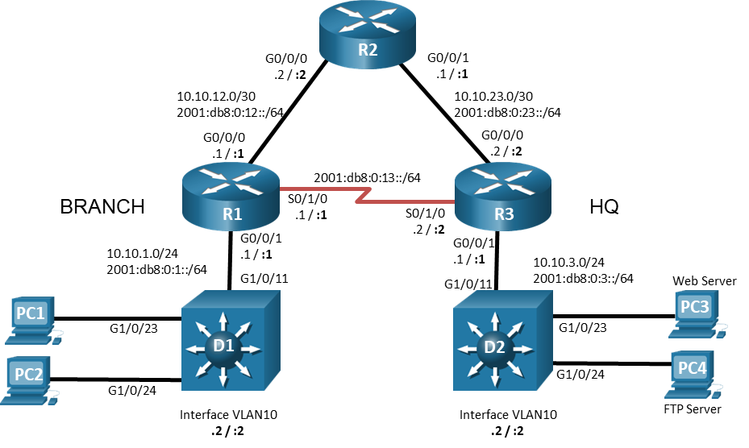

# Addressing Table

| Device | Interface | IPv4 Address/Mask | IPv6 Address/Prefix | IPv6 Link Local | Default Gateway |
| --- | --- | --- | --- | --- | --- |
| R1 | G0/0/0 | 10.10.12.1/24 | 2001:db8:0:12::1/64 | fe80::1:1 | N/A |
| R1 | G0/0/1 | 10.10.1.1/24 | 2001:db8:0:1::1/64 | fe80::1:2 | N/A |
| R1 | S0/1/0 | N/A | 2001:db8:0:13::1/64 | fe80::1:3 | N/A |
| R2 | G0/0/0 | 10.10.12.2/24 | 2001:db8:0:12::2/64 | fe80::2:1 | N/A |
| R2 | G0/0/1 | 10.10.23.1/24 | 2001:db8:0:23::1/64 | fe80::2:2 | N/A |
| R3 | G0/0/0 | 10.10.23.2/24 | 2001:db8:0:23::2/64 | fe80::3:1 | N/A |
| R3 | G0/0/1 | 10.10.3.1/24 | 2001:db8:0:3::1/64 | fe80::3:2 | N/A |
| R3 | S0/1/0 |  | 2001:db8:0:13::2/64 | fe80::3:3 | N/A |
| D1 | VLAN 10 | 10.10.1.2/24 | N/A | N/A | 10.10.1.1 |
| D2 | VLAN 10 | 10.10.3.2/24 | N/A | N/A | 10.10.3.1 |
| PC1 | NIC | 10.10.1.10/24 | 2001:db8:0:1::10/64 | EUI-64/CGA | 10.10.1.1  2001:db8:0:1::1 |
| PC2 | NIC | 10.10.1.20/24 | 2001:db8:0:1::20/64 | EUI-64/CGA | 10.10.1.1  2001:db8:0:1::1 |
| Web Server | NIC | 10.10.3.5/24 | 2001:db8:0:3::5/64 | EUI-64/CGA | 10.10.3.1  2001:db8:0:3::1 |
| FTP Server | NIC | 10.10.3.20/24 | 2001:db8:0:3::20/64 | EUI-64/CGA | 10.10.3.1  2001:db8:0:3::1 |

# Objectives

Troubleshoot network issues related to IPv4 and IPv6 static routing.

# Background / Scenario

In this topology, routers R1, R2, and R3 are configured for static routing. Switches D1 and D2 provide LAN connectivity for VLAN 10 for the respective locations. You will be loading configurations with intentional errors onto the network. Your tasks are to FIND the error(s), document your findings and the command(s) or method(s) used to fix them, FIX the issue(s) presented here and then test the network to ensure both of the following conditions are met:

* + - * 1. the complaint received in the ticket is resolved
        2. full reachability is restored

**Note**: The routers used with CCNA hands-on labs are Cisco 4221 with Cisco IOS XE Release 16.9.4 (universalk9 image). The switches used in the labs are Cisco Catalyst 3560 with Cisco IOS XE Release 16.9.4 (universalk9 image). Other routers, switches, and Cisco IOS versions can be used. Depending on the model and Cisco IOS version, the commands available and the output produced might vary from what is shown in the labs. Refer to the Router Interface Summary Table at the end of the lab for the correct interface identifiers.

**Note**: Make sure that the switches have been erased and have no startup configurations. If you are unsure, contact your instructor.

# Required Resources

* 3 Routers (Cisco 4221 with Cisco IOS XE Release 16.9.4 universal image or comparable)
* 2 Switches (Cisco 3650 with Cisco IOS XE Release 16.9.4 universalk9 image or comparable)
* 4 PCs (Choice of operating system with terminal emulation program installed)
* Console cables to configure the Cisco IOS devices via the console ports
* Ethernet cables as shown in the topology

# Instructions

## Trouble Ticket 1.1.3.1

Scenario:

An FTP Server was recently added to the HQ network. The FTP Server is accessible from all devices in the HQ network. Branch network hosts PC1 and PC2 are able to connect to the Web Server but are unable to connect to the FTP Server using IPv4.

**Note**: Web or FTP services are not required on the PCs.

Use the commands listed below to load the configuration files for both trouble tickets:

| Device | Command |
| --- | --- |
| R1 | **copy flash:/enarsi/1.1.3.1-r1-config.txt run** |
| R2 | **copy flash:/enarsi/1.1.3.1-r2-config.txt run** |
| R3 | **copy flash:/enarsi/1.1.3.1-r3-config.txt run** |
| D1 | **copy flash:/enarsi/1.1.3.1-d1-config.txt run** |
| D2 | **copy flash:/enarsi/1.1.3.1-d2-config.txt run** |

* PC 1, PC 2, FTP Server, and Web Server should be configured with the addressing listed in the Addressing Table.
* Passwords on all devices are **cisco12345**. If a username is required, use **admin**.
* After you have fixed the ticket, change the MOTD on EACH DEVICE using the following command:

**banner motd # This is $(hostname) FIXED from ticket <ticket number> #**

* Then save the configuration by issuing the **wri** command (on each device).
* Inform your instructor that you are ready for the next ticket.
* After the instructor approves your solution for this ticket, issue the **reset.now** privileged exec command. This script will clear your configurations and reload the devices.

## Trouble Ticket 1.1.3.2

Scenario:

A WAN connection through R2 was recently added to increase the bandwidth that is available between the branch and HQ. It was decided to keep the dedicated T1 connection from R1 to R3 as a backup link for IPv6 traffic. Users at the branch have been complaining that data transfer speeds to PCs at HQ seem to be slow; however, downloads seem to be fine.

Use the commands listed below to load the configuration files for both trouble tickets:

| Device | Command |
| --- | --- |
| R1 | **copy flash:/enarsi/1.1.3.2-r1-config.txt run** |
| R2 | **copy flash:/enarsi/1.1.3.2-r2-config.txt run** |
| R3 | **copy flash:/enarsi/1.1.3.2-r3-config.txt run** |
| D1 | **copy flash:/enarsi/1.1.3.2-d1-config.txt run** |
| D2 | **copy flash:/enarsi/1.1.3.2-d2-config.txt run** |

* PC 1, PC 2, FTPServer, and WebServer should be configured with the IPv6 addressing listed in the Addressing Table. It is not necessary to configure the IPv4 addresses.
* Passwords on all devices are **cisco12345**. If a username is required, use **admin**.
* After you have fixed the ticket, change the MOTD on EACH DEVICE using the following command:

**banner motd # This is $(hostname) FIXED from ticket <ticket number> #**

* Then save the configuration by issuing the **wri** command (on each device).
* Inform your instructor that you are ready for the next ticket.
* After the instructor approves your solution for this ticket, issue the **reset.now** privileged EXEC command. This script will clear your configurations and reload the devices.

# Router Interface Summary Table

| Router Model | Ethernet Interface #1 | Ethernet Interface #2 | Serial Interface #1 | Serial Interface #2 |
| --- | --- | --- | --- | --- |
| 1800 | Fast Ethernet 0/0 (F0/0) | Fast Ethernet 0/1 (F0/1) | Serial 0/0/0 (S0/0/0) | Serial 0/0/1 (S0/0/1) |
| 1900 | Gigabit Ethernet 0/0 (G0/0) | Gigabit Ethernet 0/1 (G0/1) | Serial 0/0/0 (S0/0/0) | Serial 0/0/1 (S0/0/1) |
| 2801 | Fast Ethernet 0/0 (F0/0) | Fast Ethernet 0/1 (F0/1) | Serial 0/1/0 (S0/1/0) | Serial 0/1/1 (S0/1/1) |
| 2811 | Fast Ethernet 0/0 (F0/0) | Fast Ethernet 0/1 (F0/1) | Serial 0/0/0 (S0/0/0) | Serial 0/0/1 (S0/0/1) |
| 2900 | Gigabit Ethernet 0/0 (G0/0) | Gigabit Ethernet 0/1 (G0/1) | Serial 0/0/0 (S0/0/0) | Serial 0/0/1 (S0/0/1) |
| 4221 | Gigabit Ethernet 0/0/0 (G0/0/0) | Gigabit Ethernet 0/0/1 (G0/0/1) | Serial 0/1/0 (S0/1/0) | Serial 0/1/1 (S0/1/1) |
| 4300 | Gigabit Ethernet 0/0/0 (G0/0/0) | Gigabit Ethernet 0/0/1 (G0/0/1) | Serial 0/1/0 (S0/1/0) | Serial 0/1/1 (S0/1/1) |

**Note**: To find out how the router is configured, look at the interfaces to identify the type of router and how many interfaces the router has. There is no way to effectively list all the combinations of configurations for each router class. This table includes identifiers for the possible combinations of Ethernet and Serial interfaces in the device. The table does not include any other type of interface, even though a specific router may contain one. An example of this might be an ISDN BRI interface. The string in parenthesis is the legal abbreviation that can be used in Cisco IOS commands to represent the interface.

End of document